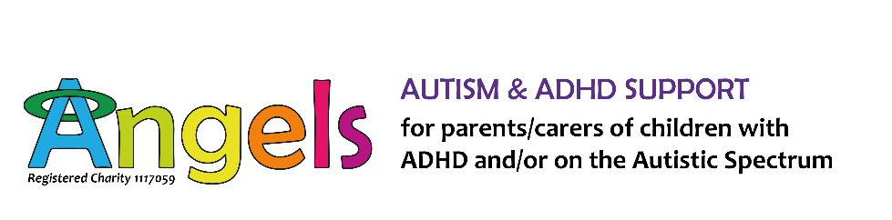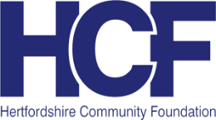

Does your child or young person have trouble getting the health care they need?

Angels can help with……
- Understanding your rights and how to ask for extra help when accessing health care.
- Strategies to help your child overcome fear and anxiety about going to the doctors/dentist/hospital etc.
- Individualised support delivered one-to-one.
- Solution focussed advice from trained, qualified parents with lived experience.
- Flexible service available face to face, by phone, email or Messenger/WhatsApp.
- Support with appointments or contacting health professionals.

Contact Penny on support@angelssupportgroup.org.uk
or on 01462 685150 to find out more

